**Converting a Production Major Havoc PCB to Support Major Havoc – The Promised End**

Draft 1.4 - 5/1/2018

Jess M. Askey – [jess@askey.org](mailto:jess@askey.org)

**Summary**

In order to support the updated ROM’s, several modifications need to be performed on the production Major Havoc PCB. The modifications are moderately challenging and you should understand that you might harm your PCB if you make mistakes, do not perform these modifications if you are not willing to accept the risks.

Overall, a few things need to be accomplished in order to run the updated ROM images.

1. Expand the Paged Alpha ROM space
2. Expand the Gamma ROM space
3. Add the speech circuitry if you want speech (technically optional)

The overall process involves adding a single IC to a ‘Spare’ location on the production PCB, adding several jumper wire and cutting one trace.

The modified PCB **\*will\*** still support running production ROM’s if you care to revert back. The cut trace specifically will not cause any functionality to be lost as it is on the speech circuit.

Note on Machine Pin Sockets vs Flat Pin Sockets: I actually find the flat sockets to work better even tho they are cheaper. The pins bend out to solder on very nicely. Also, on machine pin sockets, the bottom of the socket pin may inadvertently short to the pin in the socket below, if that happens, it may damage the circuitry. Be aware of those contact considerations.

**Parts List**

The following parts are required for each upgrade Section

Alpha + Gamma CPU (Required):

1. (1) 16-Pin DIP Socket (machine pin or flat)
2. (3) 28-Pin DIP Socket (machine pin or flat, see notes)
3. (1) 74LS174 Hex Flip-Flop

Speech Components (Optional):

1. (1) TMS5220 Speech Generator
2. (2) 74HC04 CMOS Inverter
3. (2) 2N3906 Transistors
4. (1) 2N3904 Transisitor
5. (2) 1K 1/8W resistor
6. (1) 1.8K 1/8w resistor
7. (3) 2.2K 1/8W resistor
8. (2) 10K 1/8w resistor
9. (1) 3.3K 1/8W resistor
10. (1) 100uf 16v Radial Capacitor
11. (4) .01uf 100v Radial Ceramic Capacitor
12. (1) .22uf 50v Mylar Capacitor
13. (1) LM7905 -5V Regulator
14. (1) 28-pin DIP Sockets (note: some PCB’s have the Speech IC socket already stuffed)
15. (1) 14-pin DIP Socket

**Alpha + Gamma Upgrade Procedure:**

1. Remove the ROM’s at locations 9S (Gamma) and 1Q + 1N/P (Paged ROM)
2. Solder in a 16-pin DIP socket @ location 5S.
3. Take 3 28-pin DIP sockets and bend pin 27 outwards horizontally so it will stick out when the socket is inserted, you will be soldering wires to these.
4. Plug your modified socket into the main sockets @ 9S, 1Q and 1N/P
5. On the component side, solder a wirewrap wire (30ga Kynar suggested) between pins 27 on 1Q and 1N/P. This line is the chip select for the added Paged ROM space. When you solder to the pin, I suggest that you wrap the wire around the pin so it doesn’t just pop off when you solder to it. You will be soldering another wire to the pin @ 1N/P for reference.
6. On the component side, at the socket @ 9S, solder a wire to pin 27 of the modified socket you installed. Route the wire under capacitors (see pictures below) and attach the other end to the 74LS139 IC @ 8R pin 13 (signal A14). Gamma mods are now complete.
7. Now, moving to the solder side (underside of the PCB) we will start adding the new wires for the page select.
8. Solder a wire from the new socket @ 5S, pin 1 (Reset) to the Alpha CPU 6502 @ 2S pin 40.
9. Solder a wire from the new socket @ 5S, pin 9 (Clock) to the Address Decoder 74LS138 @ 5N pin 10.
10. Solder a wire from the new socket @ 5S, pin 13 (D2) to the Data Buffer 27LS244 @ 5S pin 16.
11. Solder a LONG wire from the new socket @ 5S, pin 12. You are going to then take this wire up to a through hole in the PCB (see picture below) and then route this wire under capacitor leads to help guide the wire towards the ROM socket @ 1N/P… solder this wire neatly to pin 27 @ 1N/P.
12. We are now going to start the modifications for the speech circuit.
13. Stuff all the parts from the parts list using the below table… be careful to match polarity on the electrolytic capacitor.

Speech Upgrade steps:

1. If you do not have a socket installed @ location 10M, install one now.
2. More to come! 😊

Photos:

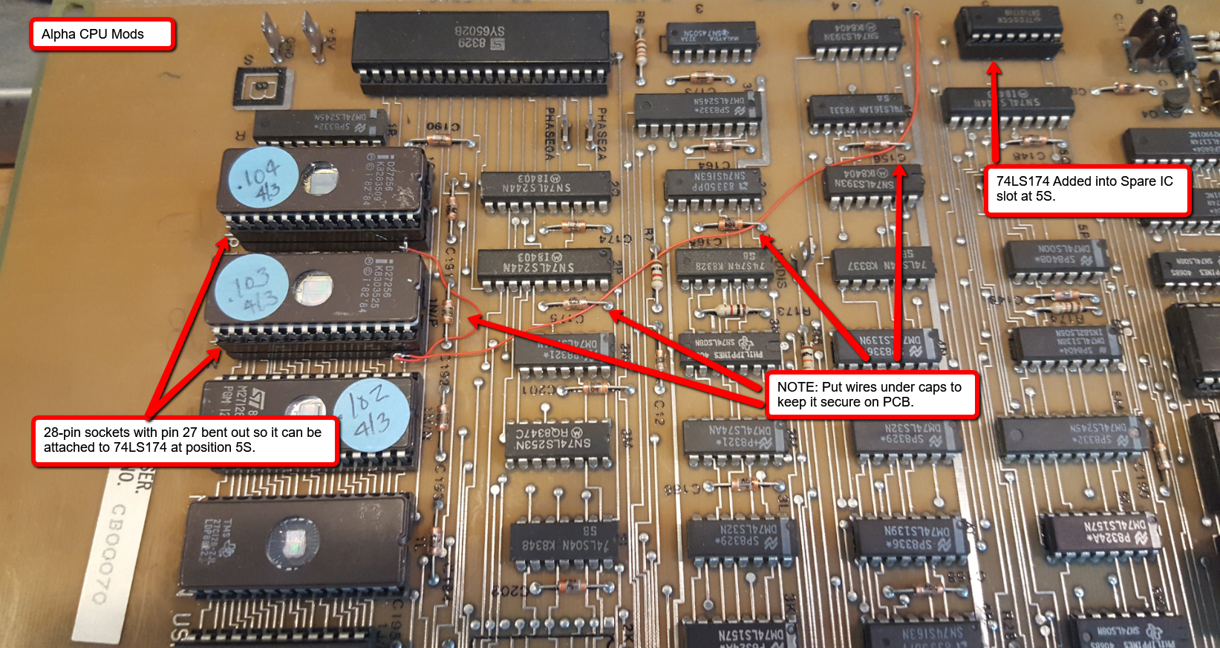

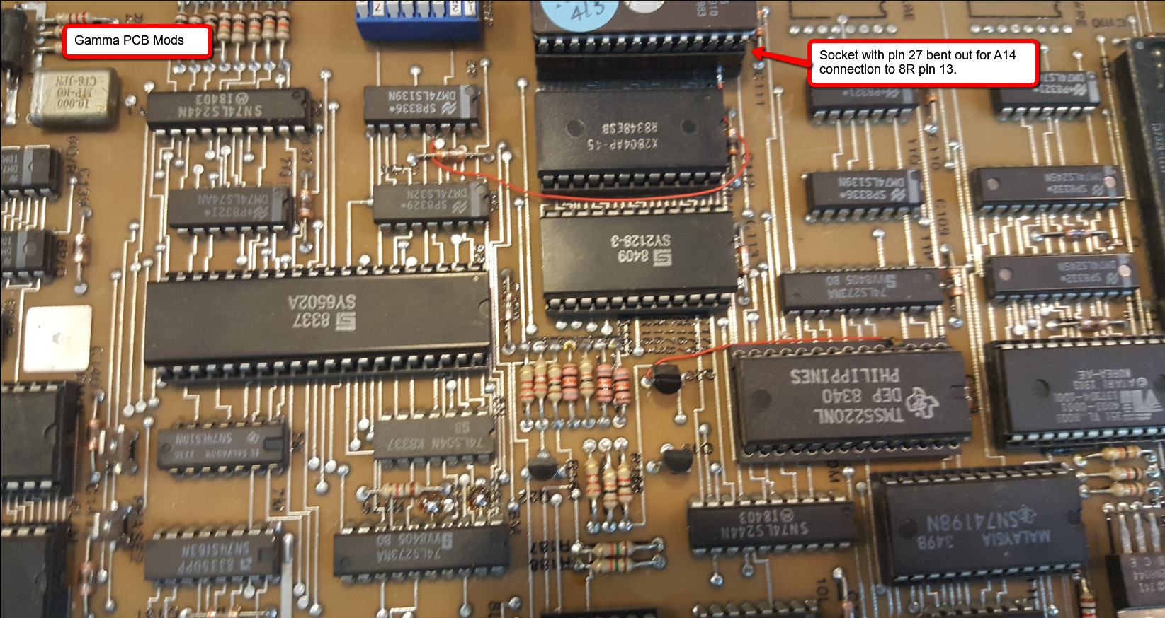

(NOTE: 5R is incorrect below, should be 5S)

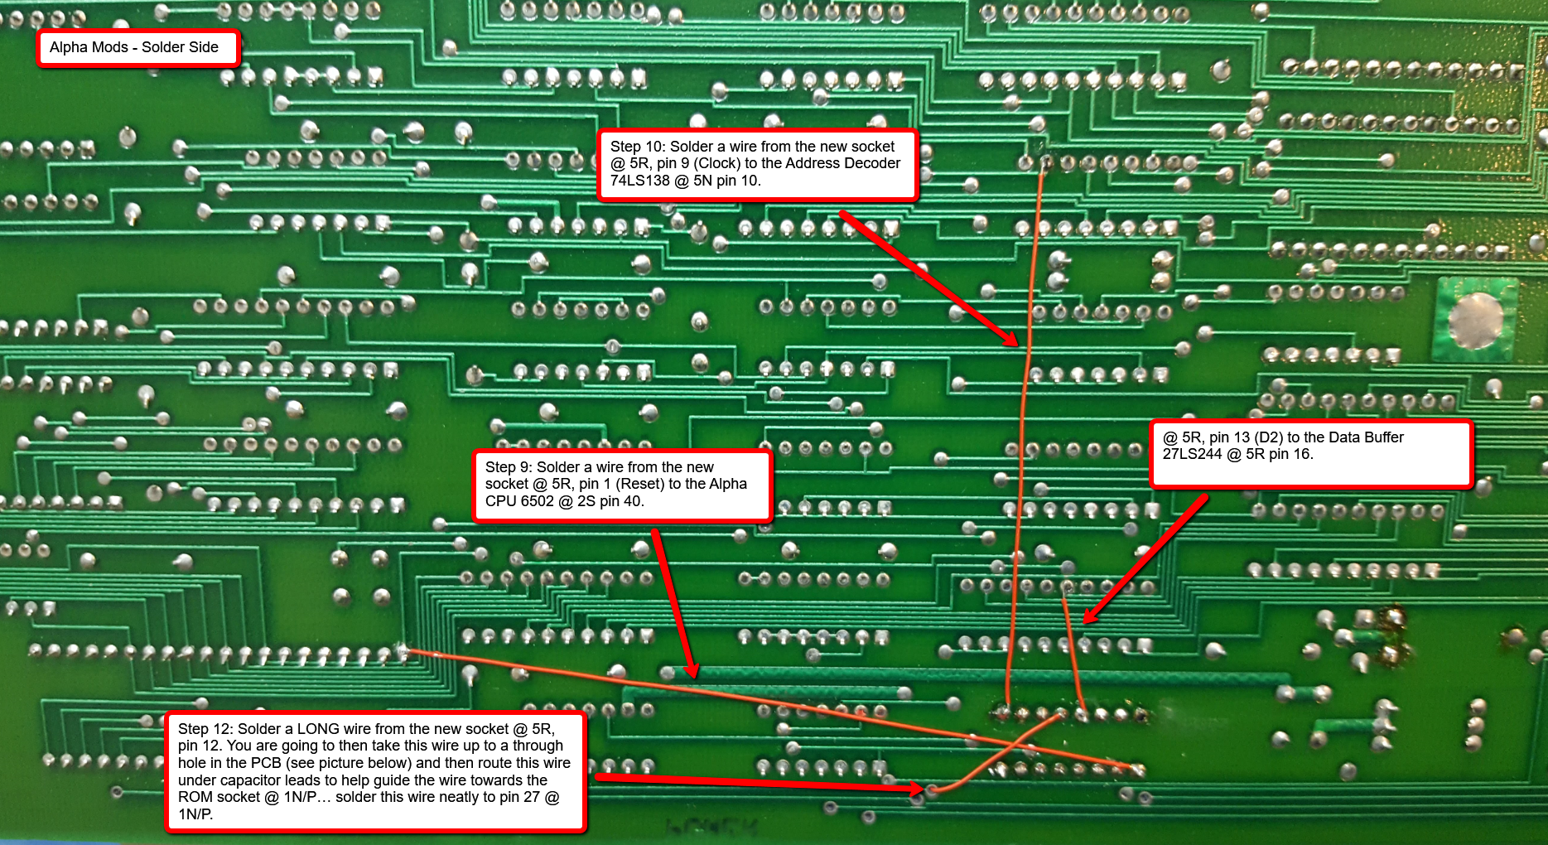

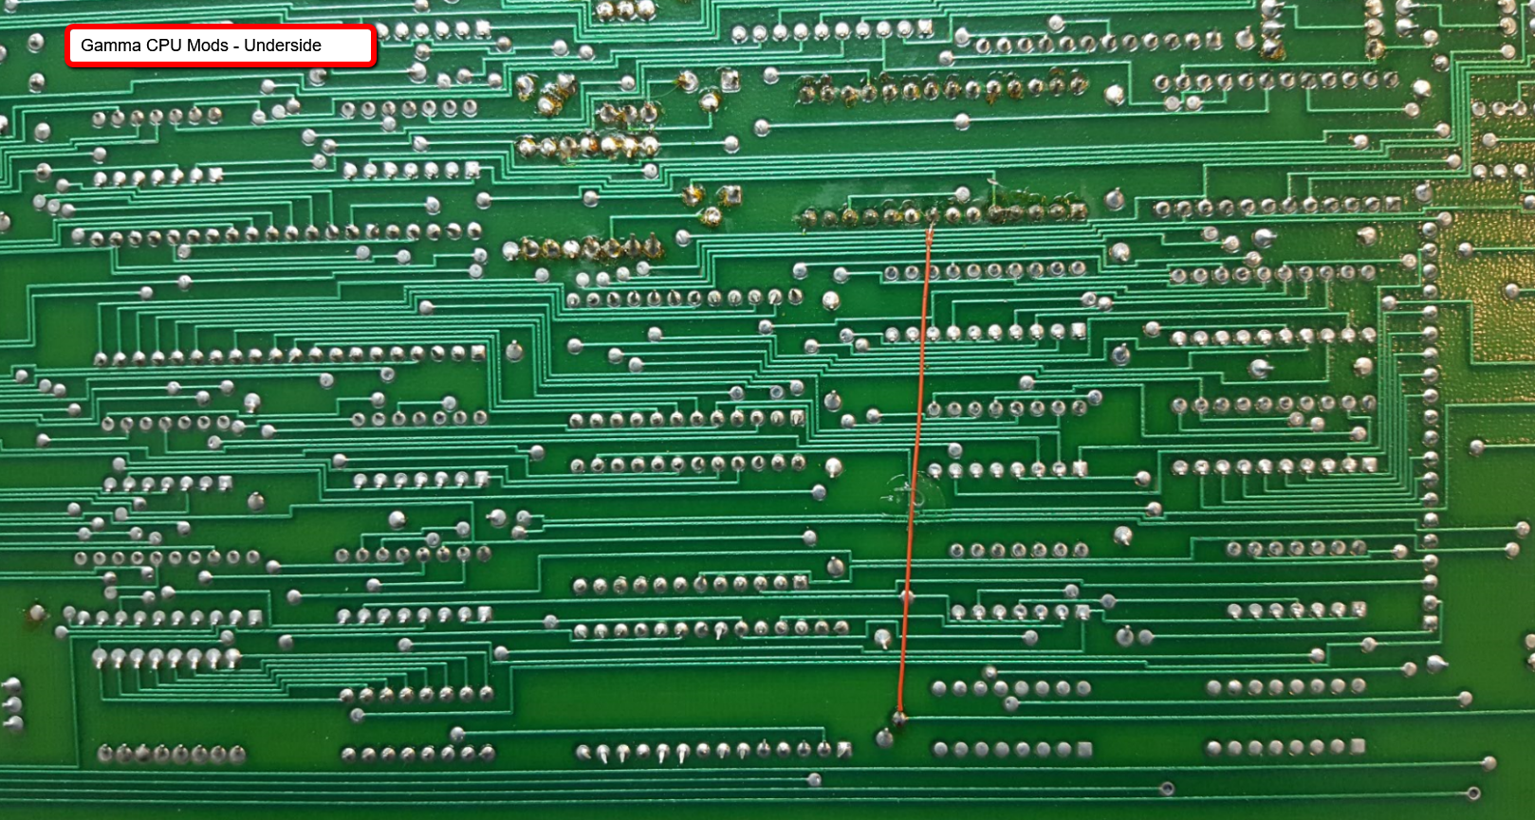

Full size Images can be found here - <https://github.com/jessaskey/mhavocpe/tree/master/Conversion/Photos>

Document History:

* Draft 1.4 – 5/1/2018 – Fixed mis-labeled location 5R with correction location 5S
* Draft 1.3 - 4/19/2018 – Added text on photos
* Draft 1.2 – 4/15/2018 – Added photos
* Draft 1.1 - ?
* Draft 1.0 - ? – Initial draft